Order No: 35 of 2025
Dated: 01-07-2025

Subject: Deployment of Mr. Shabir Ahmad Sheikh (Need base Worker).

In the interest of administration and to ensure seamless operational continuity, it is hereby ordered that Mr. Shabir Ahmad Sheikh (Need base Worker) shall report immediately to the Incharge Parks and Gardens who will serve as his reporting officer.
This directive is to facilitate his assignment to further duties as deemed necessary by the Incharge Parks and Gardens, effective from the date of this order.

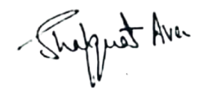

No: KGP/Estt/2025/499-500
Dated:01-07-2025
Dr. Shafquat Ara
Principal
Kashmir Govt.Polytechnic College Srinagar

Copy to:
- Incharge Parks & Gardens for information.
- Concerned official for compliance.

